### EE 351-A Electronic Circuits 1

### Dr. Peter Osterberg

**Design Report**

## Elias Taylor

## DATE: <12/02/2020>

**Introduction:**

The goal of this project was to design and simulate a single-stage Common Emitter Amplifier as shown in Fig. 4, but with unknown values for R1, R2, RE and RC. The circuit also had constraints; the amplifier must have a signal gain above 125 V/V for mid-band frequencies and also consume less than 25 mW of DC power. We were able to accomplish this by analysing the circuit's ideal values to determine the circuit's resistor values and use those values to determine node currents, node voltages, voltage gain and power consumed. The circuit was then simulated in PSPICE to compare to both the AC and DC hand analysis values as well as to generate Bode Plots for both the output voltage and phase voltage values.

**Hand Analysis:**

The first thing accomplished was determining the current values for IE and IC (current values going across each respective resistor). Using the upper and lower bounds for our current based on the constraints given it is possible to determine the upper and lower bound for our resistor value. The resistor value was then chosen first and then it was possible to determine the values for each respective current (see full hand analysis for details). We were then able to use DC analysis to determine the current values I1 and I2 for resistors R1 and R2 as seen in Fig. 1. Once DC analysis was complete we converted our circuit for AC analysis as seen in Fig. 2. We substituted the PNP transistor for the Hybrid-Pi model for analysis, then simplifying the circuit as depicted in Fig. 3. This gave us the gain as well as Rin and Rout (not given in PSPICE simulation), allowing us to determine the DC power consumption. With calculations complete we see our circuit does follow the 1/3rd rule as well as the 1/10th rule and fits the constraints of under than or equal to the power consumption of 25mW. With our values calculated we were also able to determine that the circuit conforms to Bias stability for both temperature and beta stability.

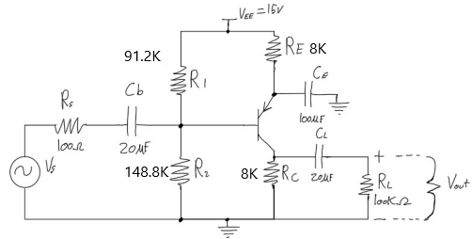

Fig 1: Hand Drawn Circuit with Resistor Values

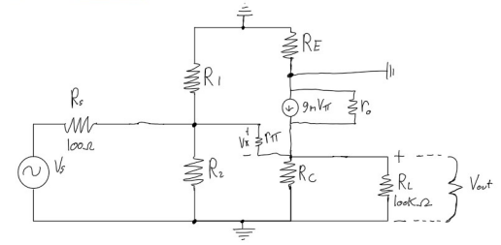

Fig 2: AC Hand Analysis

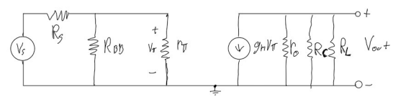

Fig 3: Simplified AC Analysis

**PSPICE Simulation:**

We then simulated the circuit in PSPICE after hand analysis was complete. We modeled the circuit using QBREAKP3 as our PNP transistor. The completed circuit modeled in PSPICE with current and voltage values can be seen in Fig. 4. We then generated a Bode plot for Vout’s Voltage Magnitude as well as the Phase value (Fig. 5), voltage magnitude in red and output voltage phase in green. PSPICE also calculated the DC power used being 9.63mW, also in the complete datasheet at the end of report as well as Table 1. The midband gain was found using the cursor value depicted in Fig. 6. The edited down datasheet for PSPICE can be seen at the end of this report.

|  |  |  |
| --- | --- | --- |
| **Parameter** | **Hand** | **PSPICE** |
| IC | 625.0 uA | 577.79 uA |
| IE | 587.5 uA | 582.73 uA |
| IB | 5.29 uA | 4.946 uA |
| IR1 | 59.21 uA | 59.43 uA |
| IR2 | 64.5 uA | 65.38 uA |
| VC | 4.66 V | 4.622 V |
| VB | 9.6 V | 9.58 V |
| VE | 10.30 V | 10.34 V |
| PDC | 9.75 mW | 9.63mW |
| Gain | -159.958 V/V | -154.265 V/V |
| Rin | 4360.61 Ω | N/A |
| Rout | 5017.29 Ω | N/A |

Table 1: Hand Calculation and Simulated Component

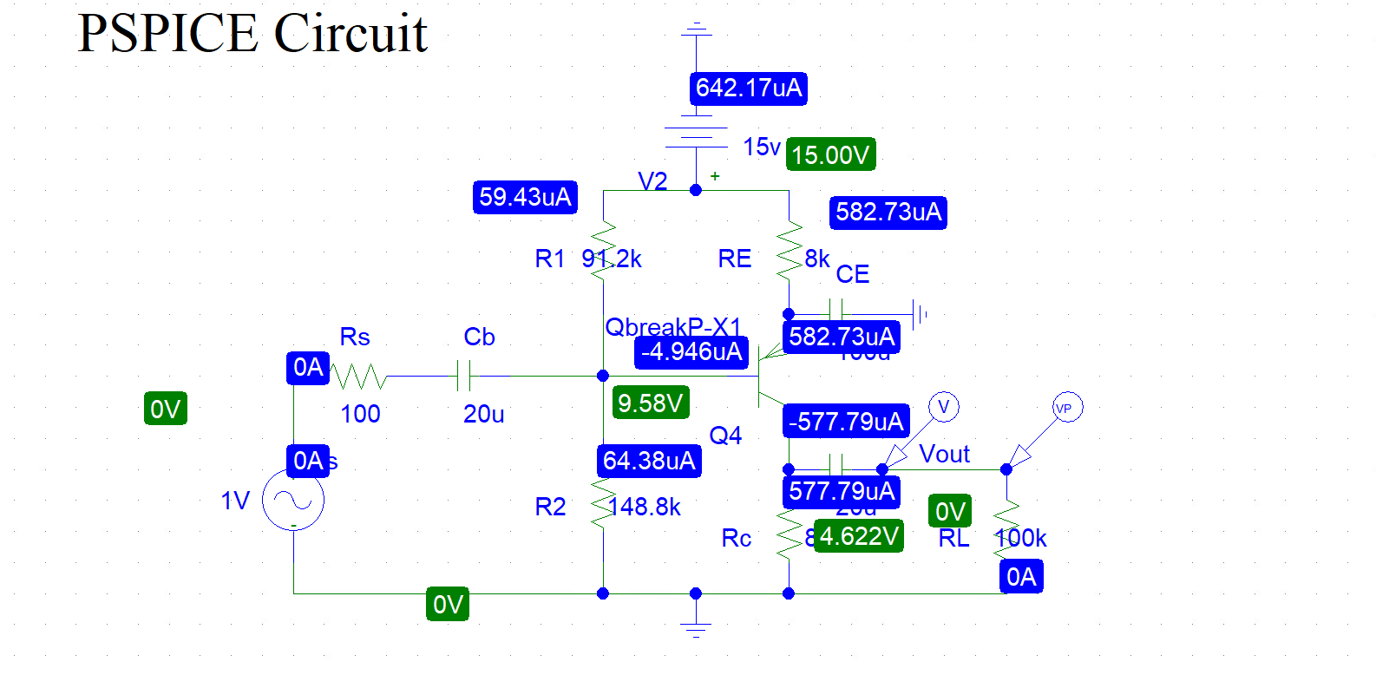

Fig 4: PSPICE Circuit Config. With Node Current & Voltage

Fig 5: Probe Cursor Value For Voltage Magn, A1 second Value is Midband Gain.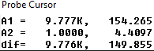

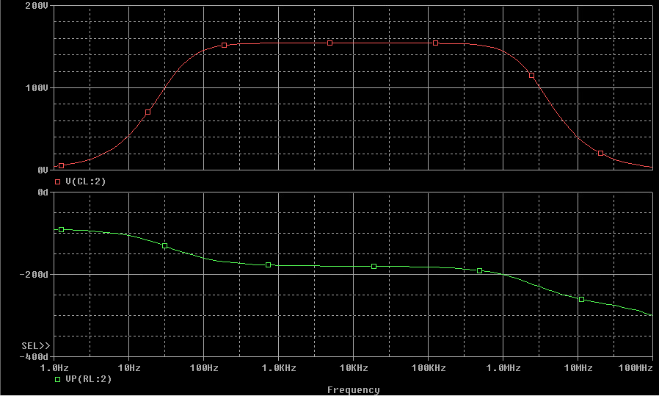

Fig 6: PSPICE Bode Plots of Output Voltage Magnitude and Phase

**Conclusion:**

Our completed values for both hand analysis and PSPICE values are recorded in Table 1 above. We had a margin of error for both AC and DC hand calculated values compared to PSPICE, but it is small enough for us to conclude that our calculations are correct as they are in an acceptable range. The margin of error may be due to rounded values by hand compounding, or because PSPICE simulates conditions not factored into our hand analysis. Over all the design goal was met, and the Current Emitter Amplifier behaves within the given constraints.

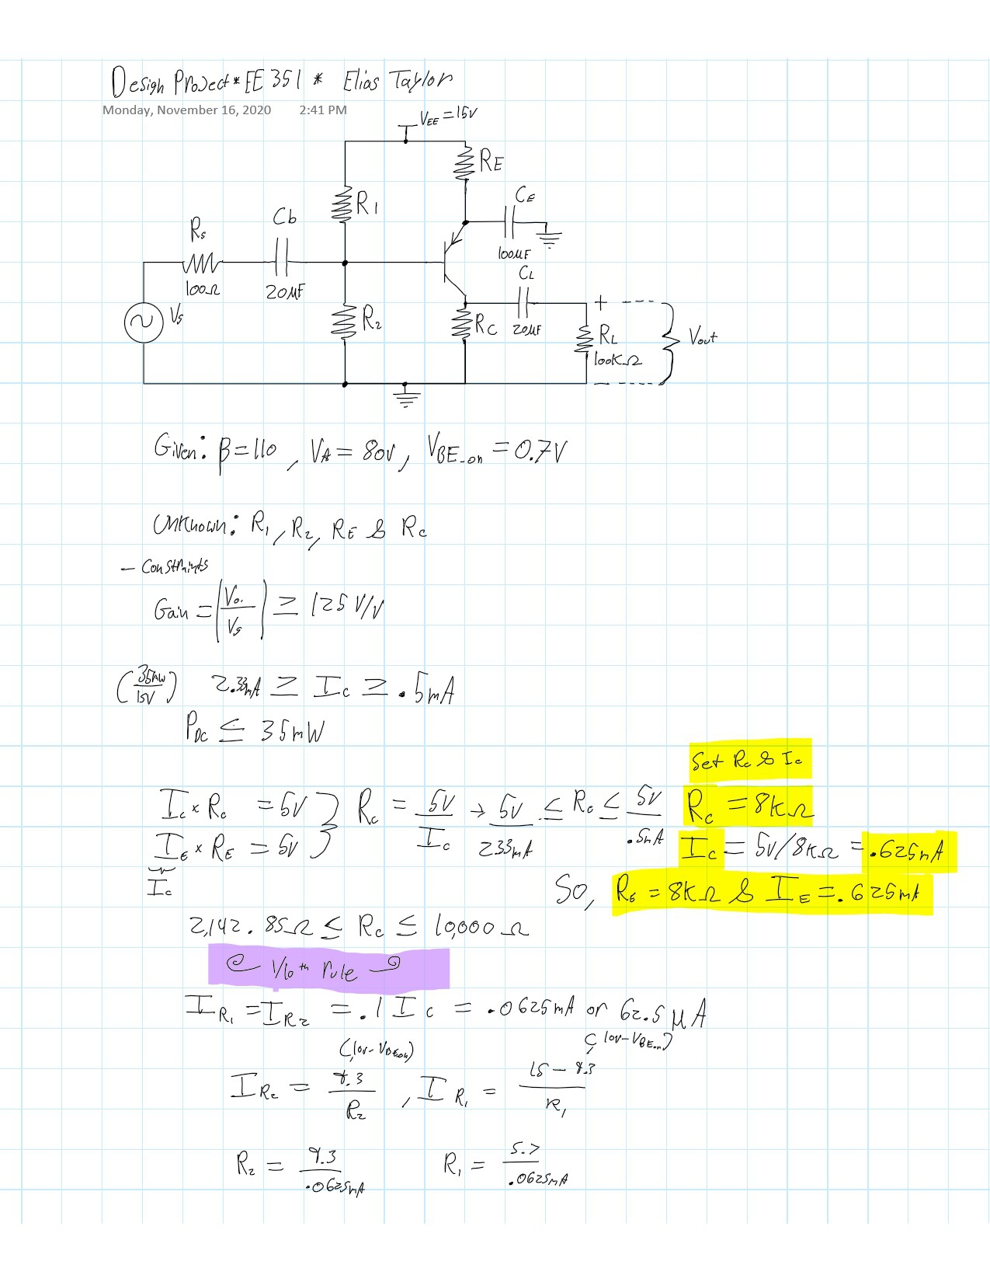

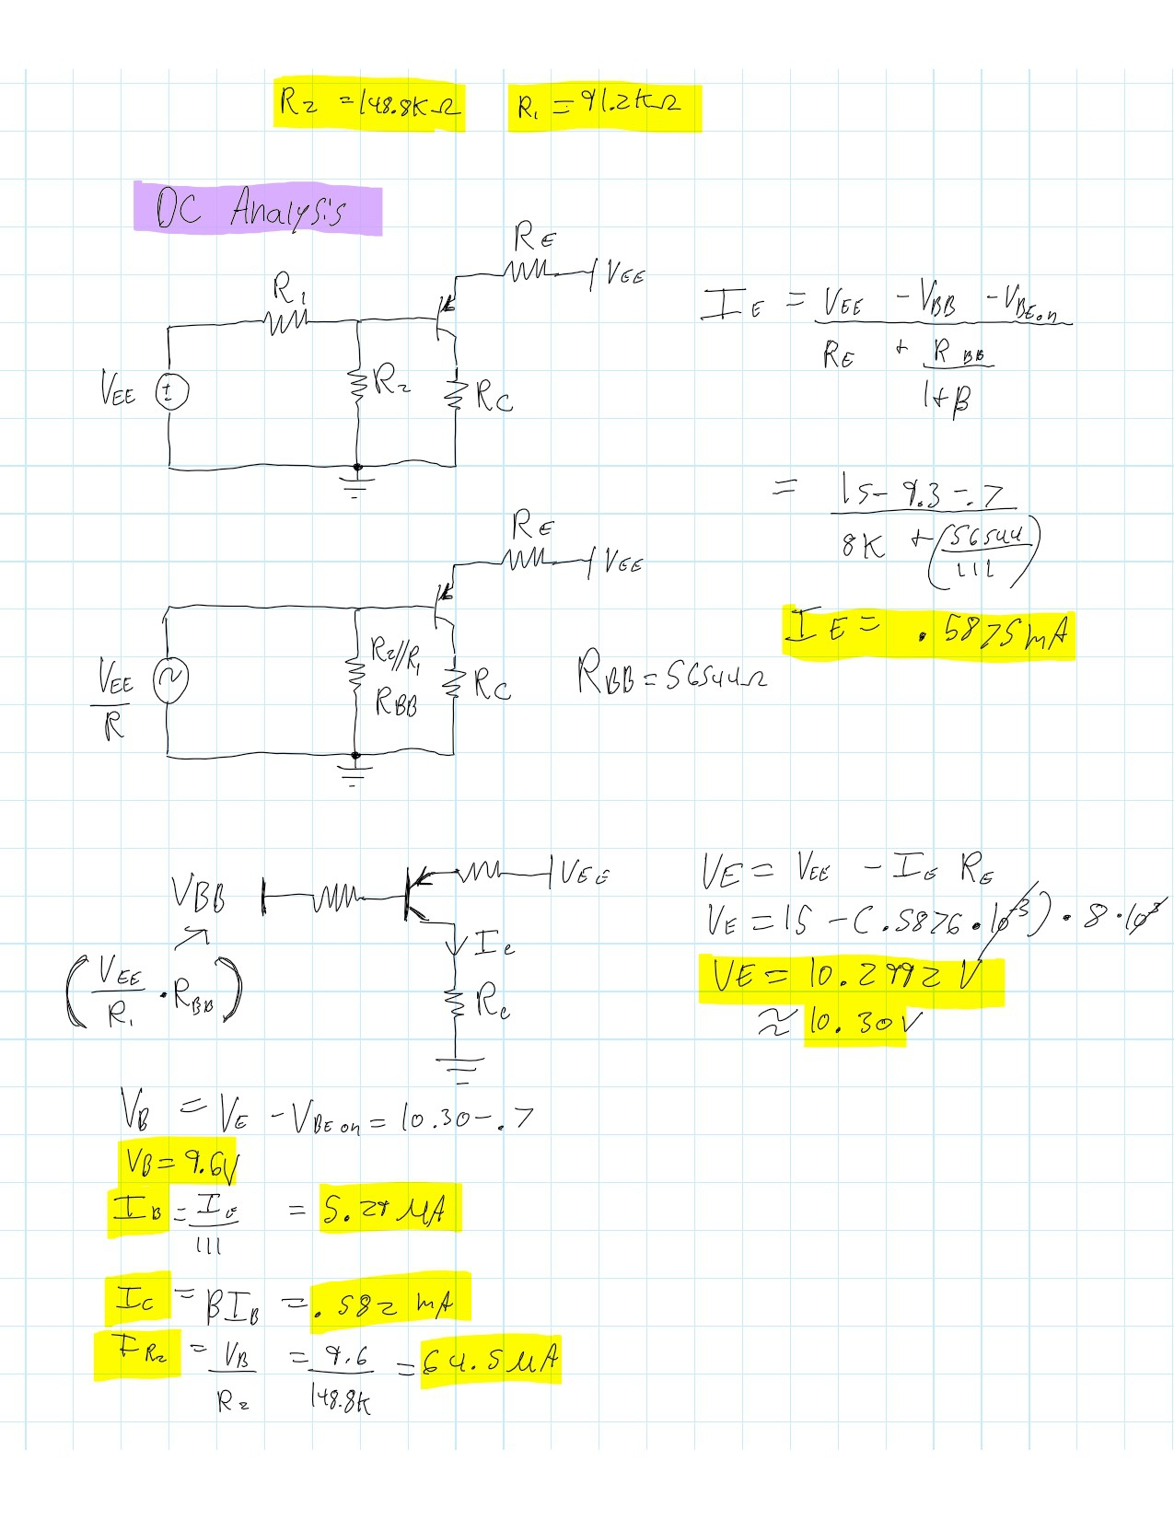

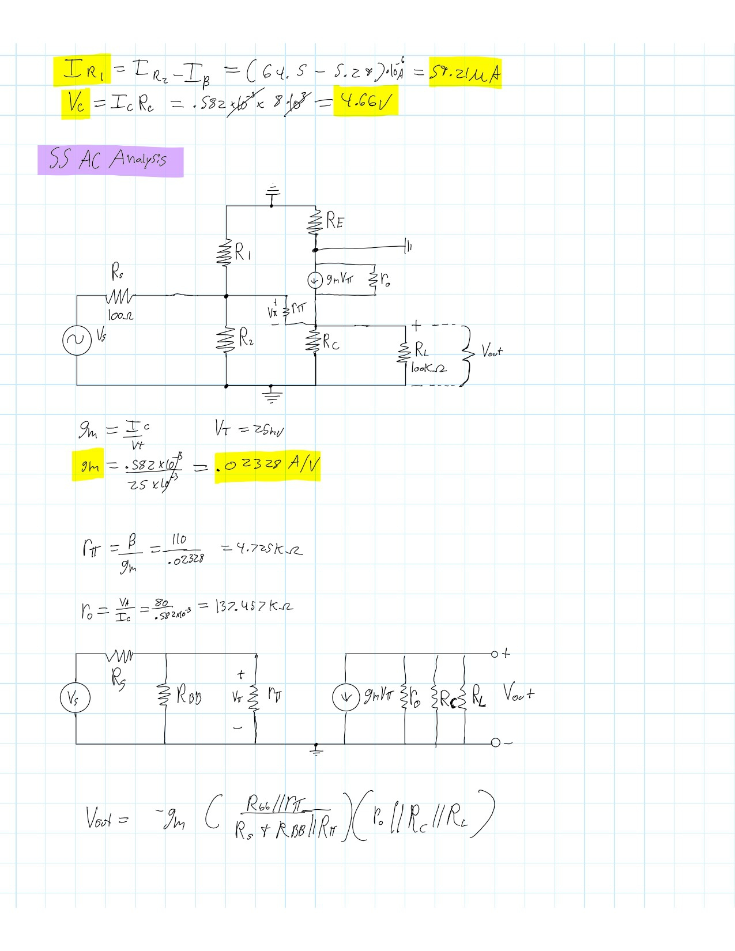

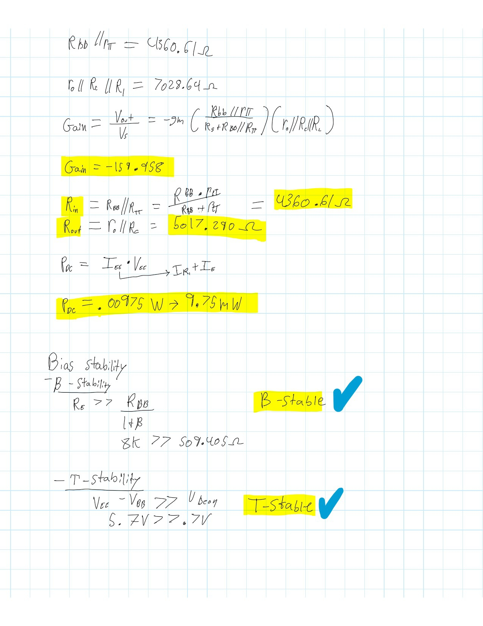

******************************************************************************

* Schematics Netlist *

C_Cb $N_0001 $N_0002 20u

C_CL $N_0003 Vout 20u

R_RL 0 Vout 100k

R_R2 0 $N_0002 148.8k

V_V2 $N_0004 0 15v

R_Rs $N_0005 $N_0001 100

V_Vs $N_0005 0 DC 0V AC 1V

R_R1 $N_0002 $N_0004 91.2k

R_Rc 0 $N_0003 8k

C_CE $N_0006 0 100u

Q_Q4 $N_0003 $N_0002 $N_0006 QbreakP-X1

R_RE $N_0006 $N_0004 8k

******************************************************************************

**** BJT MODEL PARAMETERS

QbreakP-X1

PNP

IS 100.000000E-18

BF 110

NF 1

VAF 80

BR 1

NR 1

CJE 10.000000E-12

CJC 5.000000E-12

TF 500.000000E-12

CN 2.2

D .52

******************************************************************************

NODE VOLTAGE NODE VOLTAGE NODE VOLTAGE NODE VOLTAGE

( Vout) 0.0000 ($N_0001) 0.0000 ($N_0002) 9.5797

($N_0003) 4.6223 ($N_0004) 15.0000

($N_0005) 0.0000 ($N_0006) 10.3380

VOLTAGE SOURCE CURRENTS

NAME CURRENT

V_V2 -6.422E-04

V_Vs 0.000E+00

**TOTAL POWER DISSIPATION 9.63E-03 WATTS**